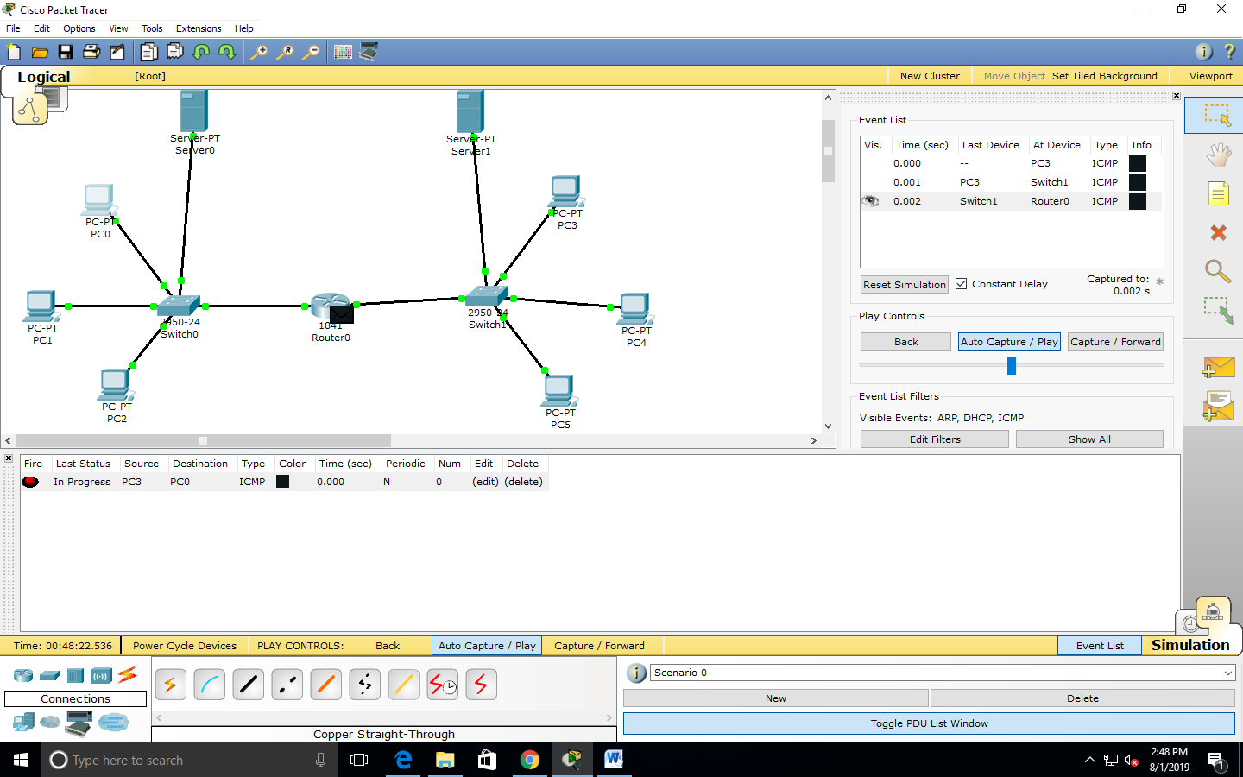

FIGURE 1: The packet travels from PC3 to the Generic Router.

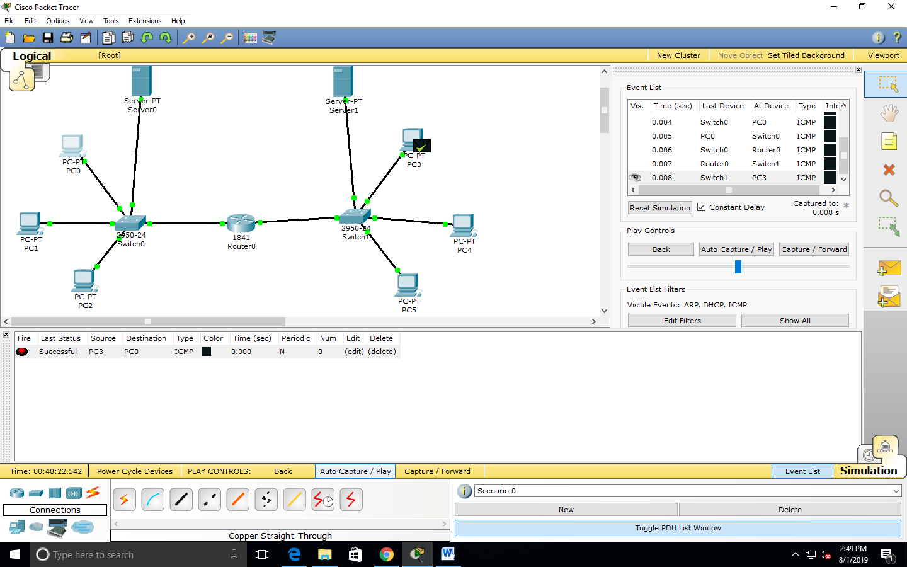

FIGURE 2: The transmission of packet from PC3 to PC0 has been successful.

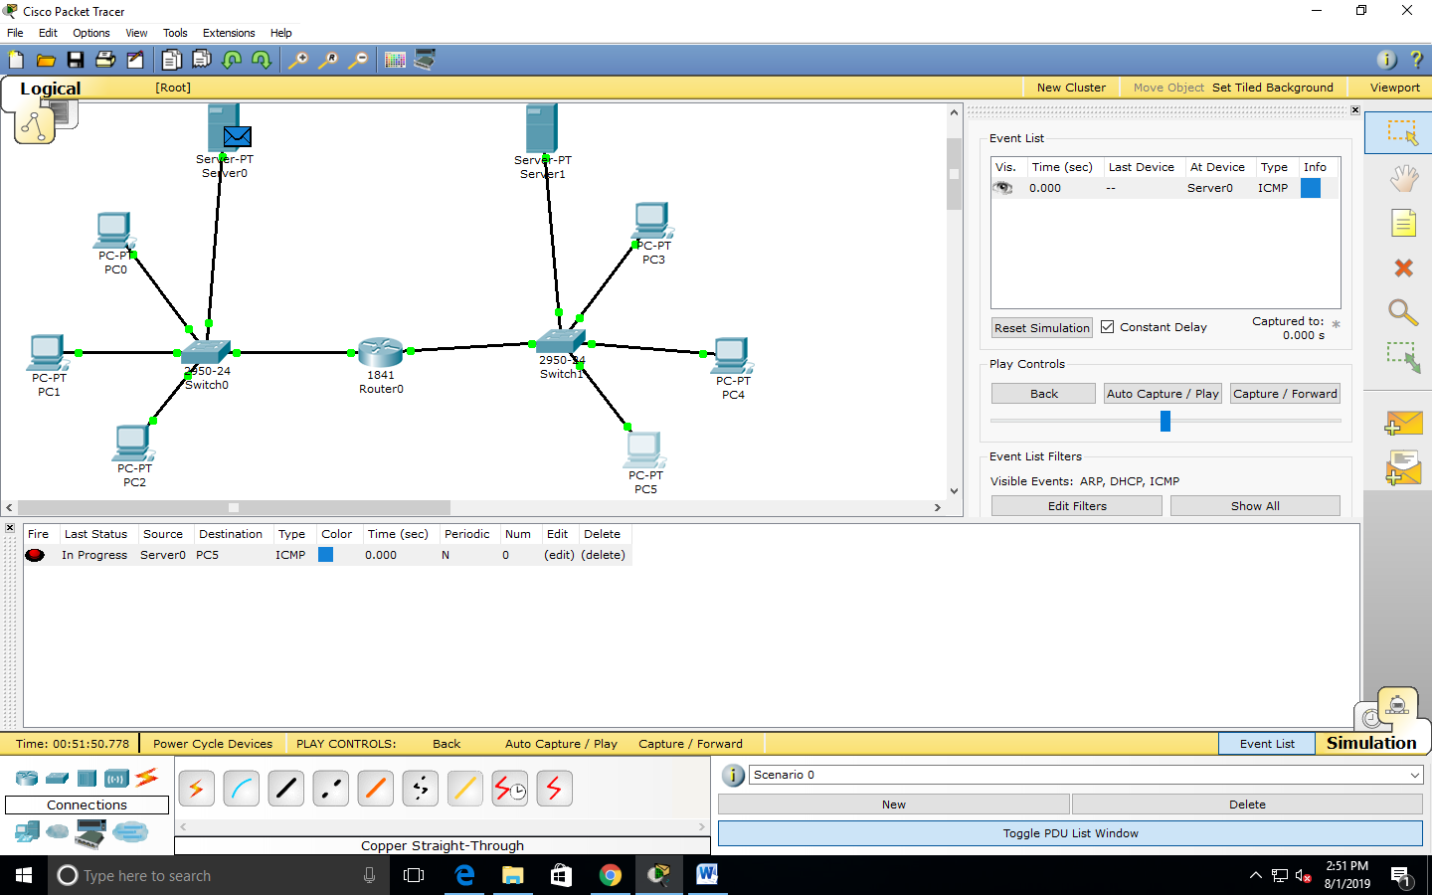

FIGURE 3: A ping is issued at Server0 to transfer the packet to PC5.

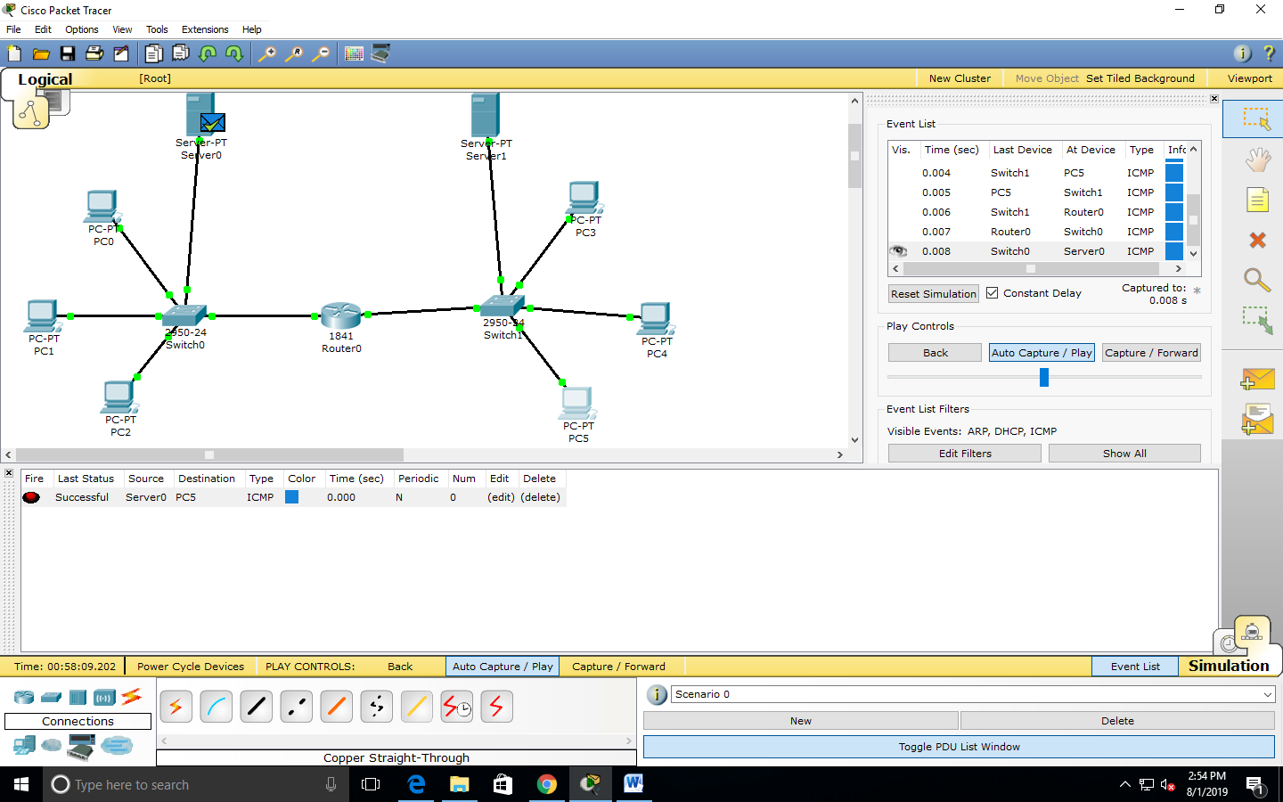

FIGURE 4: Acknowledgement is received from PC5 to Server0 after successful transfer.

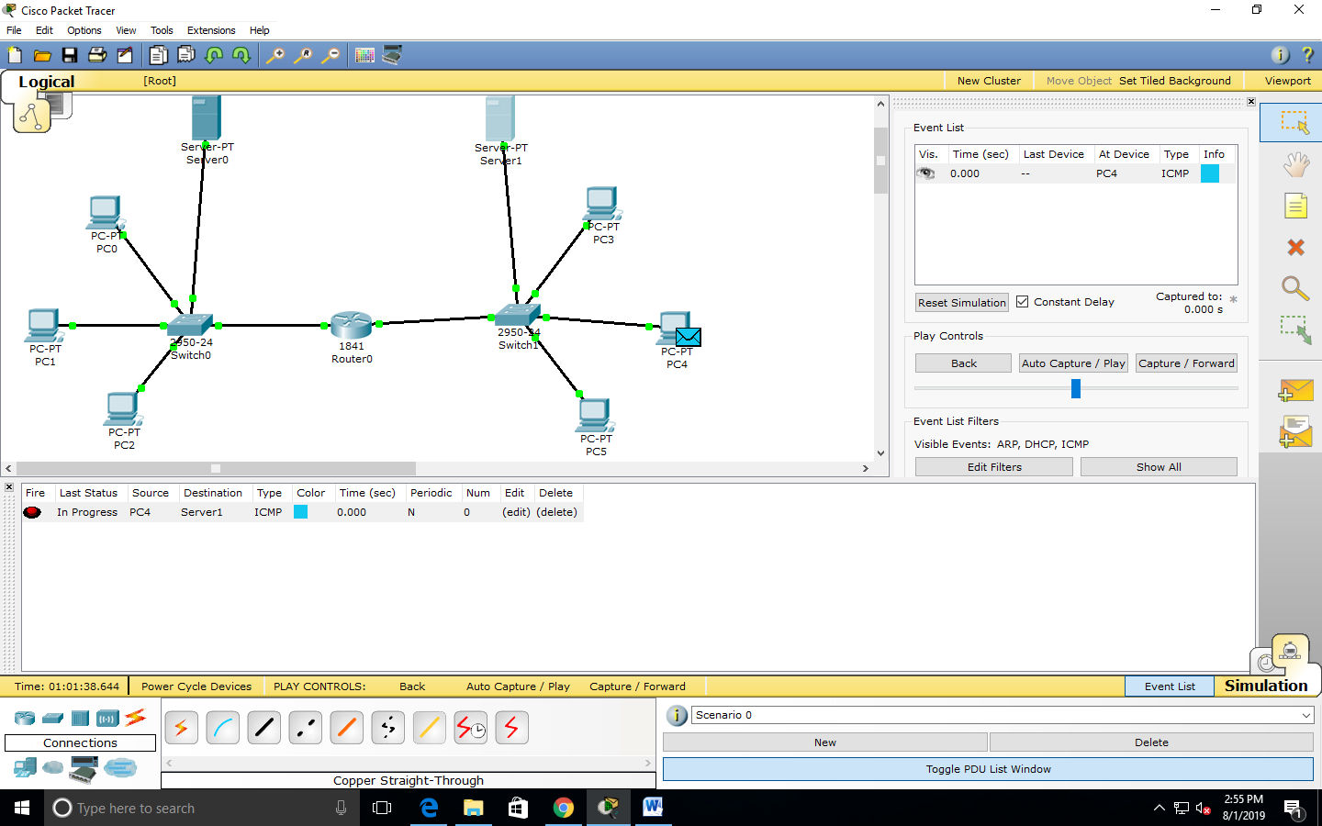

FIGURE 5: The filtered packet is being processed at PC4.

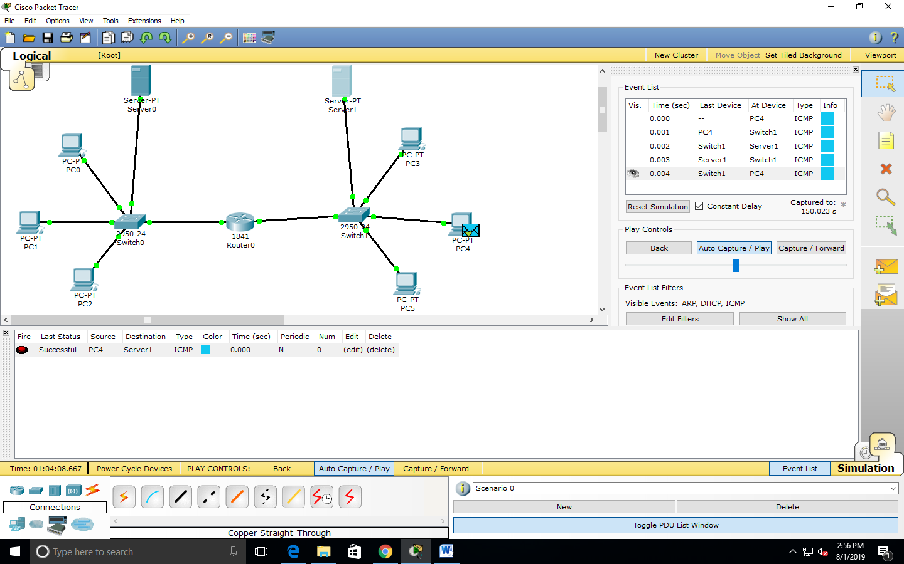

FIGURE 6: The transfer of packets has been successful from PC4 to Server1.